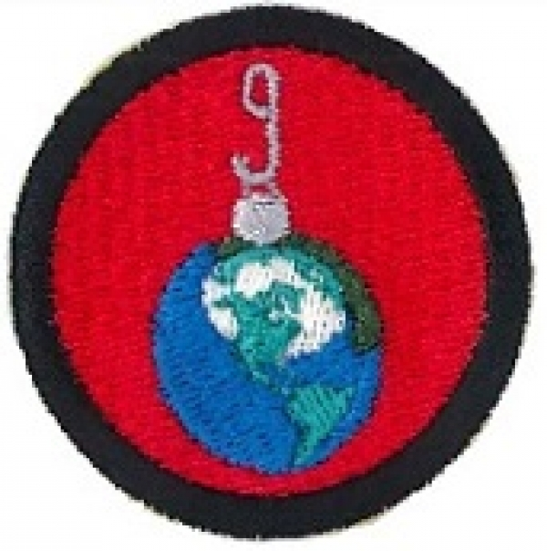
IFG Challenge
3rd Year International Cooking/Crafts/Customs Spiritual
Term Four – Weeks 1,2,3,5,6

Aim: To increase knowledge of international cooking, arts, crafts and customs around making and serving food.

Objectives:
- To challenge the girls to broaden their cooking skills by cooking meals for a special event (Christmas) taking in the customs/ culture of a particular country.
- To learn from the people of the particular countries chosen, how to serve food and dress the tables as required for the special event.

The areas of the world should be divided into five: Pacific; Asia, African, Caribbean/USA and Europe. Select one country from each of these areas to focus on.
Coaches Tip:
It is suggested that you find a person or group from these countries to assist for the evenings.
If more convenient you may decide to have these nights away from the usual IFG meeting place, it may be easier to go to where the person/or group live/meet.
Please note that for the Final Fling night (Week 7) the theme for this night is Pacific so when someone comes in to do the Pacific night of cooking, art, craft, culture etc the girls will need to learn from them how to specifically decorate a table for Christmas and any other decorations that they would put up in a room at Christmas time as they will need to do this for the invited guests on Week 7.

Preparation:
Discuss with the person/group that is coming in to teach your girls as to their requirements for the night when they are leading the session.

Devotions:
It would also be good to have the visitors take the devotional slot.

Games:
Games could be organised by the person or group taking the evening programme, or you could source some games from the internet, relevant to the country the girls are looking at.

Activities:
For these weeks, your invited guests will create their own session for the girls, sharing with them different arts, crafts and cultures from their country and relate these to a specific event, festival or Christmas. They will teach them how to cook a special dish or food from their country, show how it is served and how the tables would be dressed for this special event.
Note: For Week 7 (Final Fling) the girls will need to know how to dress a table for a Christmas event.

Closing Prayer

Home time & notices:
IFG Challenge
3rd Year International Cooking/Crafts/Customs Spiritual
Term Four – Week 4

Aim: To tie dye fabric to make a lava-lava.

Preparation:
- Gather together all equipment necessary to tie dye fabric.
- Enough white pre-washed fabric, each girl needs 2 metres x 1 metre.
- Set up tables; cover these with plastic rubbish bags with several layers of newspaper on top.
- Have several large waterproof pots/buckets (depends on the size of your group of girls).

Games:
Leaders or girls choice.

Devotions:
Leader’s choice.

Activity:
Make a tie dyed lava-lava.
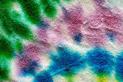
Note: This activity is to give the girls a change in focus and also prepare for the Week Seven activity.

Instructions:
Materials:
1 piece of cotton material sized 2metres x 1 metre (Washed)
Rubber bands or string
Buttons to tie into fabric before dyeing – these make great patterns
Newspaper
Rubber Gloves
Hot water dye
Garbage bags

Method:
Here are some basic instructions for tie-dyeing along with some helpful hints and tips.
1. Before you dye your item, you should wash it to remove any sizing from the fabric and anything else that may be on the fabric.
2. Decide what sort of design you want for your finished project.
3. Lay your item out flat first and then fold and tie as desired. (Suggest that girls look on the internet for ideas).
4. Cover your work area so the dye doesn't stain it. Cover by laying down a few large garbage bags and then put newspaper on top of that.
5. Prepare your dye as directed by the manufacturer. You should carefully follow all instructions. While preparing the dye and dyeing your item, you should wear rubber gloves to protect your hands from staining, and from the hot water.
6. Start dyeing! It is usually best to start with the lightest colour if you are using more than one colour. Rinse or wait between colours as directed by the manufacturer. Make sure to follow all directions carefully when it comes to dyeing and rinsing the items. Some dyes require you to rinse immediately and others require you to let the item sit for at least 24 hours.
7. When your dyeing is complete, make sure you clean all containers immediately with hot soapy water.
8. Be careful washing your tie-dyed items! Most should be washed in cold water. The first few times they are washed, they might bleed, so wash them with like colors or alone.
Again, the exact directions you follow will vary depending on what brand of dye you use. Read all instructions and precautions carefully.
Note: There is one thing you should remember when tie-dyeing, no matter what brand of dye you use, every tie-dyed item will be different, as everyone will use different techniques and colours.

Coaches Tips:
It would be a good idea to have plenty of helpers for this activity.

Closing prayer:

Notices:

IFG Challenge
3rd Year International Cooking/Crafts/Customs Spiritual
Term Four – Week 7 Final Fling

Aim: Awards night and Final Fling


Objectives:
- The Pacific country the girls have learned about will be the focus of the night.
- Invite friends, family and the people who helped the girls learn about the various customs, crafts and cooking from other countries.
- Girls are to wear their lava-lava tonight.

Preparation for the night before everyone arrives:
- Have the girls decorate the room using skills they have learned.
- Girls to decorate the tables for a special Christmas event.
- Have the girls prepare at least 3 dishes and set them out on the table, together with necessary utensils or finger bowls etc.

Everyone is here!
- Have the girls welcome, guests, friends and families.
- Invite pastor or some else to say grace.
- Eat the meal according to Pacific Customs (girls will be expected to serve visitors first).
- Follow this with Devotions and some games from the Pacific.
- Presentation of Awards

Closing Prayer:

Notices and Home

